Ramakrishna Mission Shilpamandira Computer Center

Project

Student Management System

Name: Ritesh Tiwari

Course: CCA

Roll: 7C

Batch: 16G/2017

Project Topic: Student Management System

**Software use**: Visual Basic 2010 ,MS Access , Windows 10

**Hardware use**: CD , Printer, Monitor , Keyboard , Mouse

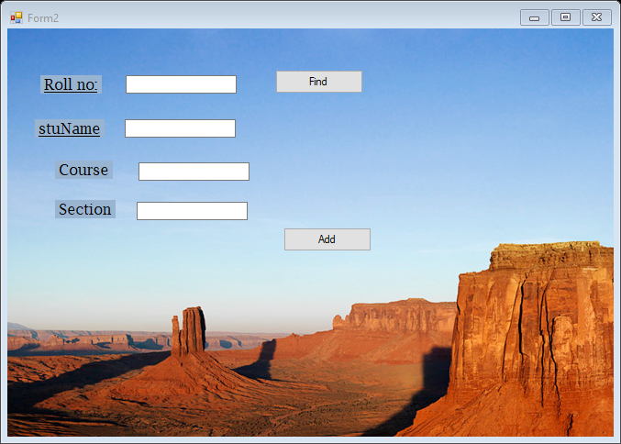

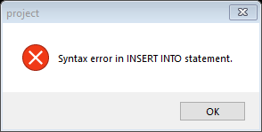

ImportsSystem.Data.OleDb

PublicClassForm2

DimcnAsNewOleDbConnection

Dim cm AsNewOleDbCommand

DimdrAsOleDbDataReader

PublicSubconnection()

cn = NewOleDb.OleDbConnection

Withcn

.ConnectionString = "Provider=Microsoft.Jet.OLEDB.4.0;Data Source=D:\Ritesh Tiwari\sample.mdb"

.Open()

EndWith

EndSub

PrivateSub Form2_Load(ByVal sender AsSystem.Object, ByVal e AsSystem.EventArgs) HandlesMyBase.Load

Callconnection()

EndSub

PrivateSub Button4_Click(ByVal sender AsSystem.Object, ByVal e AsSystem.EventArgs) Handles Button4.Click

Try

cm = NewOleDb.OleDbCommand

With cm

.Connection = cn

.CommandType = CommandType.Text

.CommandText = "Insert into Result(RoolNo,stuName,course,Section)"

.Parameters.Add(NewSystem.Data.OleDb.OleDbParameter("@Rool No", System.Data.OleDb.OleDbType.VarChar, 255, Me.TextBox1.Text))

.Parameters.Add(NewSystem.Data.OleDb.OleDbParameter("@course", System.Data.OleDb.OleDbType.VarChar, 255, Me.TextBox3.Text))

.Parameters.Add(NewSystem.Data.OleDb.OleDbParameter("@stu Name", System.Data.OleDb.OleDbType.VarChar, 255, Me.TextBox2.Text))

.Parameters.Add(NewSystem.Data.OleDb.OleDbParameter("@Section", System.Data.OleDb.OleDbType.VarChar, 255, Me.TextBox4.Text))

cm.Parameters("@Rool No").Value = Me.TextBox1.Text

cm.Parameters("@course").Value = Me.TextBox3.Text

cm.Parameters("@stu Name").Value = Me.TextBox2.Text

cm.Parameters("@Section").Value = Me.TextBox4.Text

cm.ExecuteNonQuery()

MsgBox("Record Save.", MsgBoxStyle.Information)

Me.TextBox1.Text = ""

Me.TextBox2.Text = ""

Me.TextBox3.Text = ""

Me.TextBox4.Text = ""

Exit Sub

EndWith

Catch ex AsException

MsgBox(ex.Message, MsgBoxStyle.Critical)

EndTry

EndSub

EndClass

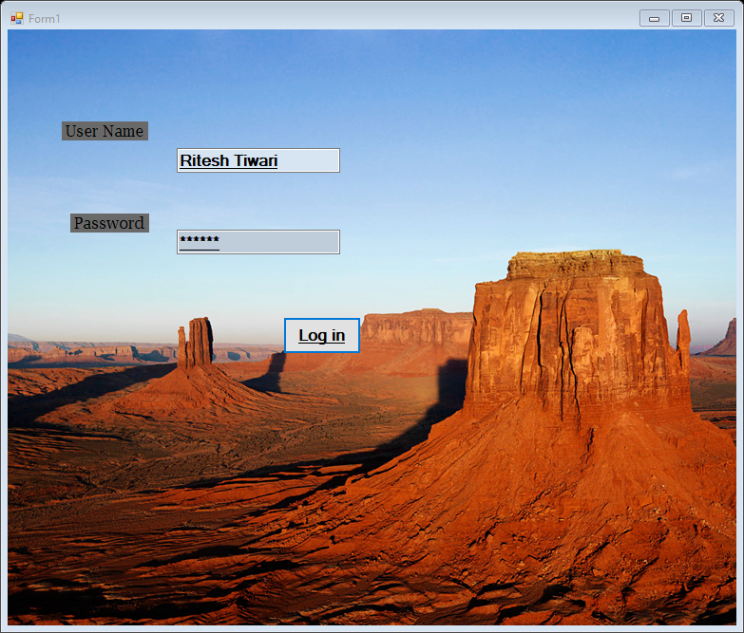

PublicClassForm1

PrivateSub Form1_Load(ByVal sender AsSystem.Object, ByVal e AsSystem.EventArgs) HandlesMyBase.Load

EndSub

PrivateSub Button3_Click(ByVal sender AsSystem.Object, ByVal e AsSystem.EventArgs) Handles Button3.Click

If TextBox1.Text = "RiteshTiwari"And TextBox2.Text = "211211"Then

Form2.Show()

Else

MessageBox.Show(" Sorry, The User Name or Password was incorrect.")

EndIf

EndSub

PrivateSub TextBox1_TextChanged(ByVal sender AsSystem.Object, ByVal e AsSystem.EventArgs) Handles TextBox1.TextChanged

EndSub

EndClass